SANSKAAR PATNI
180905134 CSE -C 23
OS LAB6

1. MESSAGE QUEUE PALINDROME

//sender.c
#include <stdlib.h>
#include <stdio.h>
#include <string.h>
#include <errno.h>
#include <unistd.h>
#include <sys/types.h>
#include <sys/ipc.h>
#include <sys/msg.h>

struct my_msg_st{
long int my_msg_type;
int some_integer;
};

int main()
{
int a=0;
int running=1;
struct my_msg_st some_data;
int msgid = msgget((key_t)1234,0666|IPC_CREAT);
if(msgid==-1)
{
fprintf(stderr,"msgget failed!!\n");
exit(EXIT_FAILURE);
}
while(running){
printf("Enter a number(-999 to exit): ");
some_data.my_msg_type=1;
scanf("%d",&a);
some_data.some_integer=a;
if(msgsnd(msgid, &some_data, sizeof(int),0)==-1)
{
printf("msgsnd failed!!!\n");
exit(EXIT_FAILURE);
}
if(a==-999){
running=0;
}
}
exit(EXIT_SUCCESS);
}

//reciever.c
#include <stdlib.h>
#include <stdio.h>
#include <string.h>
#include <errno.h>
#include <unistd.h>
#include <sys/types.h>
#include <sys/ipc.h>
#include <sys/msg.h>

struct my_msg_st{
long int my_msg_type;
int some_integer;
};

int main()
{
int a=0;
int running=1;
struct my_msg_st some_data;
int msgid = msgget((key_t)1234,0666|IPC_CREAT);
if(msgid==-1)
{
fprintf(stderr,"msgget failed!!\n");
exit(EXIT_FAILURE);
}
while(running){
if(msgrcv(msgid, &some_data, sizeof(int),0,0)==-1)
{
printf("msgsnd failed!!!\n");
exit(EXIT_FAILURE);
}
else
{
a=some_data.some_integer;
printf("Recieved Number: %d\n",a);
int p = a;
int r=0,s=0;
while(p!=0)
{
r=p%10;
s=s*10+r;
p=p/10;
}
if(s==a)
printf("Palindrome Number!!\n");
else
printf("NOT Palindrome Number\n");
if(a==-999){
running=0;
}
}
}
if(msgctl(msgid,IPC_RMID,0)==-1){
fprintf(stderr, "msgctl(IPC_RMID) failed\n");
}
exit(EXIT_SUCCESS);
}
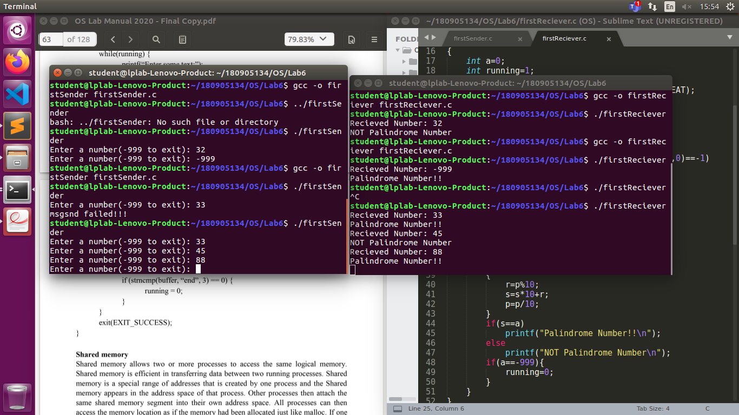
2. Shared memory character update
#include <stdlib.h>
#include <stdio.h>
#include <string.h>
#include <errno.h>
#include <unistd.h>
#include <sys/types.h>
#include <sys/ipc.h>
#include <sys/shm.h>

struct shared_use
{
char c;
char next_char;
};
int main()
{
int running = 1;
int status;
void *shared_memory = (void *)0;
int shmid;
struct shared_use *stuff;
srand((unsigned int)getpid());
shmid = shmget((key_t)1234,sizeof(struct shared_use),0666|IPC_CREAT);
if(shmid==-1)
{
fprintf(stderr,"shmget failed!!\n");
exit(EXIT_FAILURE);
}
shared_memory = shmat(shmid,(void *)0,0);
if(shared_memory == (void *)-1)
{
fprintf(stderr, "shmat failed\n");
exit(EXIT_FAILURE);
}
stuff = (struct shared_use *)shared_memory;
char ch;
printf("Enter a character: \n");
scanf("%c",&ch);
stuff->c=ch;
int pid=fork();
if(pid==0){
shmid = shmget((key_t)1234,sizeof(struct shared_use),0666|IPC_CREAT);
shared_memory = shmat(shmid,(void *)0,0);
if(shared_memory == (void *)-1)
{
fprintf(stderr, "shmat failed\n");
exit(EXIT_FAILURE);
}
stuff = (struct shared_use *)shared_memory;
printf("In child..");
printf("current char: %c\n",stuff->c);
printf("Updating character..\n");
stuff->c++;
if(shmctl(shmid,IPC_RMID,0)==-1)
{
fprintf(stderr, "shmctl(IP_RMID) failed\n");
exit(EXIT_FAILURE);
}
}else if(pid>0){
wait(&status);
printf("In parent..\n");
printf("current char: %c\n",stuff->c);
}
if(shmdt(shared_memory)==-1)
{
fprintf(stderr, "shmdt failed\n");
exit(EXIT_FAILURE); }
}
